Mustang V-Labs - Instructions for Windows to Windows
Official URL: https://services.smsu.edu/TDClient/180/Portal/KB/Article/1059/Mustang-V-Labs-Instructions-for-Windows-to-Windows
Category: Knowledge Base > Information Technology Services > Software and Applications > Mustang V-Labs - Instructions for Windows to Windows
Tags: network, access, vlabs, mustangvlabs, remote, lab, windows
_____________________________________________________
ATTENTION:
- Your username is: campus\YourStarID (i.e., smsu.edu\ab1234cd)
- Your password is: your StarID password
- Remember to save your files to OneDrive or email them to yourself and log off. Files saved directly on these computers will be deleted.
- Click or type the link below in a new browser to see different computers available. You can connect to any of the listed computers by clicking the "Connect" button to the right of desired computer: https://remoteaccess.labstats.com/Southwest-Minnesota-State-University.
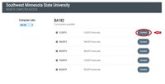
Figure 1: Uploaded Image (Thumbnail)
- Clicking the "Connect" button for your desired computer prompts you to download and open the connection file, followed by the listed steps.
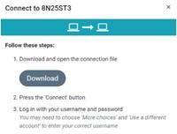
Figure 2: Uploaded Image (Thumbnail)
- Once downloaded, open the file. The remote desktop connection will automatically pop up. Click "Connect" to proceed.
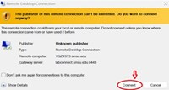
Figure 3: Uploaded Image (Thumbnail)
- Once it is connected, log in with your user account and password to gain access.
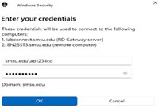
Figure 4: Uploaded Image (Thumbnail)
- Always remember to save your files and log off the computer when you are finished using it.
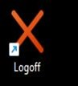
Figure 5: Uploaded Image (Thumbnail)
Accessibility Review & Update Log:
- [ ] Content accuracy verified
- [ ] Color contrast checked
- [x] Image alt-text verified (screenshots auto-captioned)
- [x] Document structure and headings formatted (perfect bold, list bulletpoints and sequences preserved)

